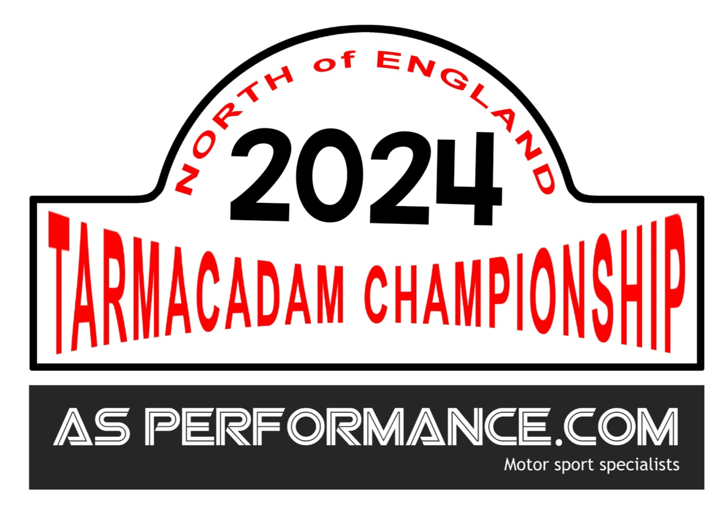
North of England Tarmacadam Rally Championship

Neville Simmons & Nicky Jackson Championship Managers
C/O 11, Ropsley Close, Church Fields, New Hartley, Whitley Bay NE25 0GJ
Tel: 03330020569 email: hello@nerallychamp.co.uk



2024 Sign On Form
(please print clearly thank you)
Event Class Entered : …………………………………………………………………………………………….
2024 Championship Class: Class 1/Class 2/Class 3/Class 4/Class 5/Class 6/Class 7.
Make…………………………………………………………… Model.………………………………………………………………………
Car Details
Event Start Number…………………………………………………….
Telephone Home………………………………………………………….Mobile……………………………………………………….
I am signing on for event……………………..………………………………………………………………………………
Contenders Name……………………………………………………………………………………………………………………………..

form may be scanned/copied and emailed to
manager@nerallychamp.co.uk or sent via Whattsapp to 07889141828


Use the QR Code for electronic 2024 Sign On form

